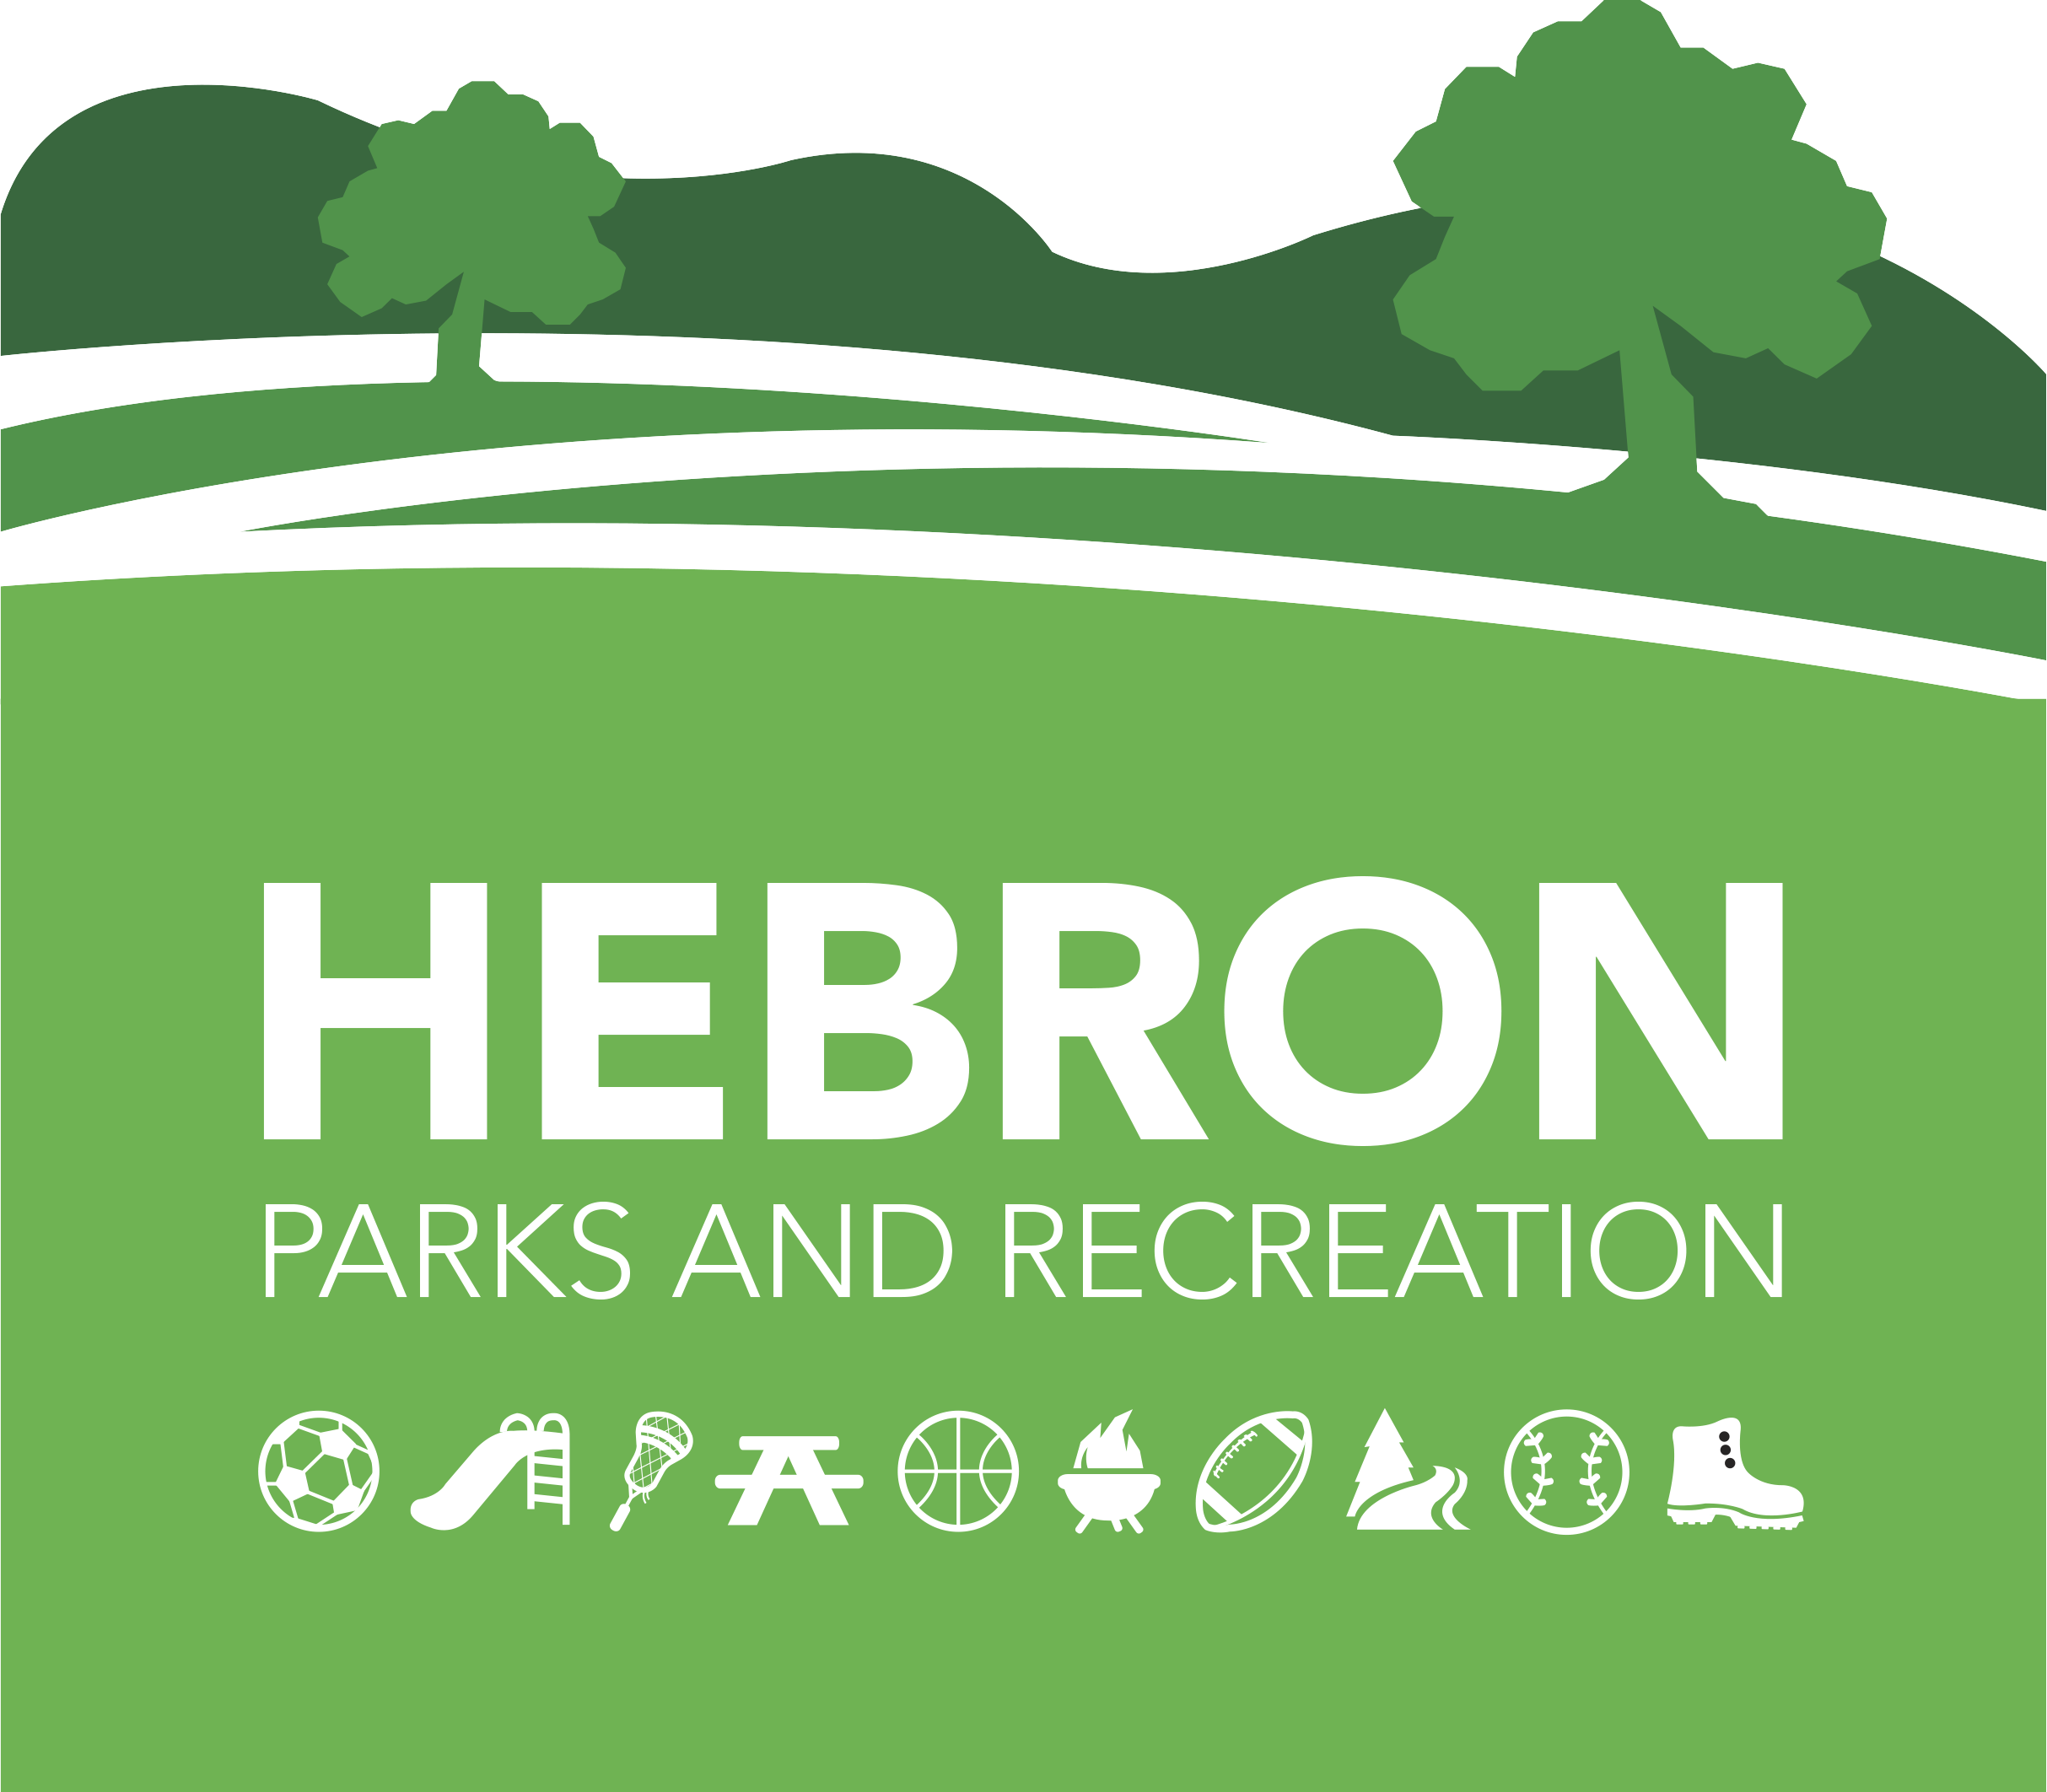
Hebron Parks & Recreation Department
Mailing Address Office Location
15 Gilead Street 148 East Street
Hebron, CT 06248 Hebron, CT 06248
860-530-1281 www.hebronct.recdesk.com/community
860-228-5912 Fax

2025-2026 PREP Registration
Grades Pre-K- 6th

Dear PREP Families,

Families with children currently enrolled in the PREP Program have priority for re-enrollment and the opportunity to enroll a sibling for the upcoming year. To maintain this priority status, your currently enrolled PREP child(ren) must complete the current program year.

To reserve your spot for next year, please complete and return the attached registration packet along with all required forms and a deposit. The deposit, which will be applied toward the first month of your PREP tuition, is $100 for one child or $150 for a family of two or more.

The deposit will be credited to your September tuition. Checks should be made payable to “Town of Hebron.” While the deposit is non-refundable, you may relinquish your place at any time by notifying the Recreation Supervisor in writing. The remaining balance for the first month of PREP is due by August 9, 2025. Please note that registration will not be accepted without all completed paperwork and a credit card on file.

If you have any questions, please do not hesitate to contact the Parks and Recreation office at
860-530-1281.

Thank you,

Erica Santos
Recreation Supervisor

Hebron Parks & Recreation Department
Mailing Address Office Location
15 Gilead Street 148 East Street
Hebron, CT 06248 Hebron, CT 06248
860-530-1281 www.hebronct.recdesk.com/community
860-228-5912 Fax

DOCUMENT CHECKLIST

- Deposit *not accepted without

- PREP Enrollment Reservation Form

- Signed Contract

- Emergency Contact/ Pick-up Form

- Credit Card Authorization Form *not accepted without

- Authorization for the Administration of Medication *if applicable

- Transfer of Confidential Student Information *if applicable

- Tuition Fee Schedule (please keep for your records)

- Completed Transportation Pick Up/Drop off Request Form *not accepted without

- Must attach up to date immunization records for each child *not accepted without

- Program and Weather Cancellation policy *not accepted without

- I have received and read the PREP Parent Handbook-

Parent/Guardian Signature: _______________________________ Date: _______________

Hebron Parks & Recreation Department
Mailing Address Office Location
15 Gilead Street 148 East Street
Hebron, CT 06248 Hebron, CT 06248
860-530-1281 www.hebronct.recdesk.com/community
860-228-5912 Fax

PREP ENROLLMENT RESERVATION 2025-2026

Parent/ Guardian Name: _______________________________ Phone: _________________

Address: _____________________________________________________________

Cell: ___________________ Email: _______________________________________

Parent/ Guardian Name: _____________________________ Phone: ___________________

Address: _____________________________________________________________

Cell: ___________________E-Mail: ______________________________________

Please list each child separately.
Please mark, on the appropriate line, to indicate the type of care you wish to reserve for each child.
Child’s Name | Date of Birth | Grade in Sept 2025 | AM Care 6:45-8am | PM Care 2:45-5pm | PM Extended Care  5 –6:00pm

To complete your PREP registration, please submit this completed registration packet to-

By mail-
Hebron Parks & Recreation Department
15 Gilead Street
Hebron, CT 06248

In person-
Hebron Parks & Rec. Office
Burnt Hill Park
148 East Street
Hebron, CT 06248
Town of Hebron, Parks & Recreation
PREP Contract
Effective August 27, 2025, through June 10, 2026*

I, ______________________________________________, have read, understand, and hereby agree to abide by the policies set forth by the Town of Hebron Parks & Recreation Enrichment Program (PREP). All my questions have been asked and answered, and I agree to abide by the policies of the program.

_____ I agree to pay the tuition for my child(ren) on a monthly basis, according to the specifications of the Monthly Payment Schedule. Tuition is due on the third Friday of the preceding month.

_____ I agree to pay all incurred late fines or fees for additional program hours, as necessary.

____ I agree that my credit card will be kept on file and will be charged the day after the due date.

_____ I agree to provide two weeks’ written advance notice to the Parks & Recreation Office for the purpose of scheduling vacation time for my child.

_____ I agree to provide two weeks written advance notice with payment to the Parks & Recreation office if I choose to withdraw my child(ren) from the program.

School Vacations and Staff Development Days are an additional fee. I also understand that my child is not guaranteed a slot for Vacation and Staff Development days, and that sign-up for these weeks will be on a first-come, first-served basis.
I understand that failure to abide by the program policies may result in my being asked to find more appropriate care for my child elsewhere.

**I do give permission to have my child(ren) photographed and/ or videotaped for use in the Parks & Recreation Enrichment Program and/ or by Town of Hebron Parks & Recreation Department. I understand that the photograph(s) and/or videotapes will be used for activity purposes or for publications.

I hereby give approval for my child to participate in the above listed Hebron Parks & Recreation Department program. I agree to assume all risks and hazards incidental to this program(s), including transportation to and from the site of said program. I hereby waive, absolve, indemnify, and agree to hold harmless the Town of Hebron, the department, the commission, supervisors, instructors, and participants from claims arising out of injury to myself/ my child. Any injuries will have to be covered by the individual's insurance.

____________________________________ _______________________
Signature of Parent/ Guardian Date

*Subject to change based on the school calendar

Hebron Parks & Recreation PREP
Pick-Up & Emergency Contact Reference 2025-2026

Child’s Name: ________________________ D.O.B. _________________ Grade: ________

Address: _____________________________________________ Phone # _______________

List any allergies or medical conditions:______________________________________________
______________________________________________________________________________

List any medications taken regularly:________________________________________________

______________________________________________________________________________

Parent/ Guardian’s Parent/ Guardian’s
Full Name:___________________________ Full Name:_______________________________

Address: _____________________________ Address: _________________________________

Home # ____________Work/Cell___________ Home # ____________Work/Cell____________

Email_________________________________ Email___________________________________

List (3) Other Individuals who should be contacted, to pick-up or call, if neither parent can be reached:

Name: _________________________Phone:_______________ Relation to child: ______________

Name: _________________________Phone:_______________ Relation to child: ______________

Name: _________________________Phone: ______________ _Relation to child: ______________

Child’s Pediatrician: _____________________Town: ______________ Phone:_________________

Hospital Preference: ________________________________________________________________

In case of an emergency, I give permission for Hebron Parks and Recreation Enrichment Program (PREP) to provide my child with medical attention as deemed necessary.

Parent/Guardian Signature____________________________________ Date_______________________

Parent/ Guardian Signature____________________________________ Date_______________________

Hebron Parks & Recreation Department
Mailing Address Office Location
15 Gilead Street 148 East Street
Hebron, CT 06248 Hebron, CT 06248
860-530-1281 www.hebronct.recdesk.com/community
860-228-5912 Fax

Credit Card Authorization

*Registration will not be taken unless we have a credit card on file.

Child(ren) Name:___________________________________________________________________

Street:________________________________________ Town: __________________Zip__________

Credit Card Information:

Credit Card Type_______________________ Credit Card #__________________________________
Exp. Date____________ 3-digit CVV #: _____________

I authorize that my credit card be kept on file and will be charged five days after the due date.

I hereby authorize the Hebron Parks & Recreation Department to credit my charge card for monthly Tuition payments to the “PREP” program, and any other charges which I specifically authorize.

Printed Name: ______________________________________ Date: _____________________

Signature: ___________________________________________ Date: ______________________

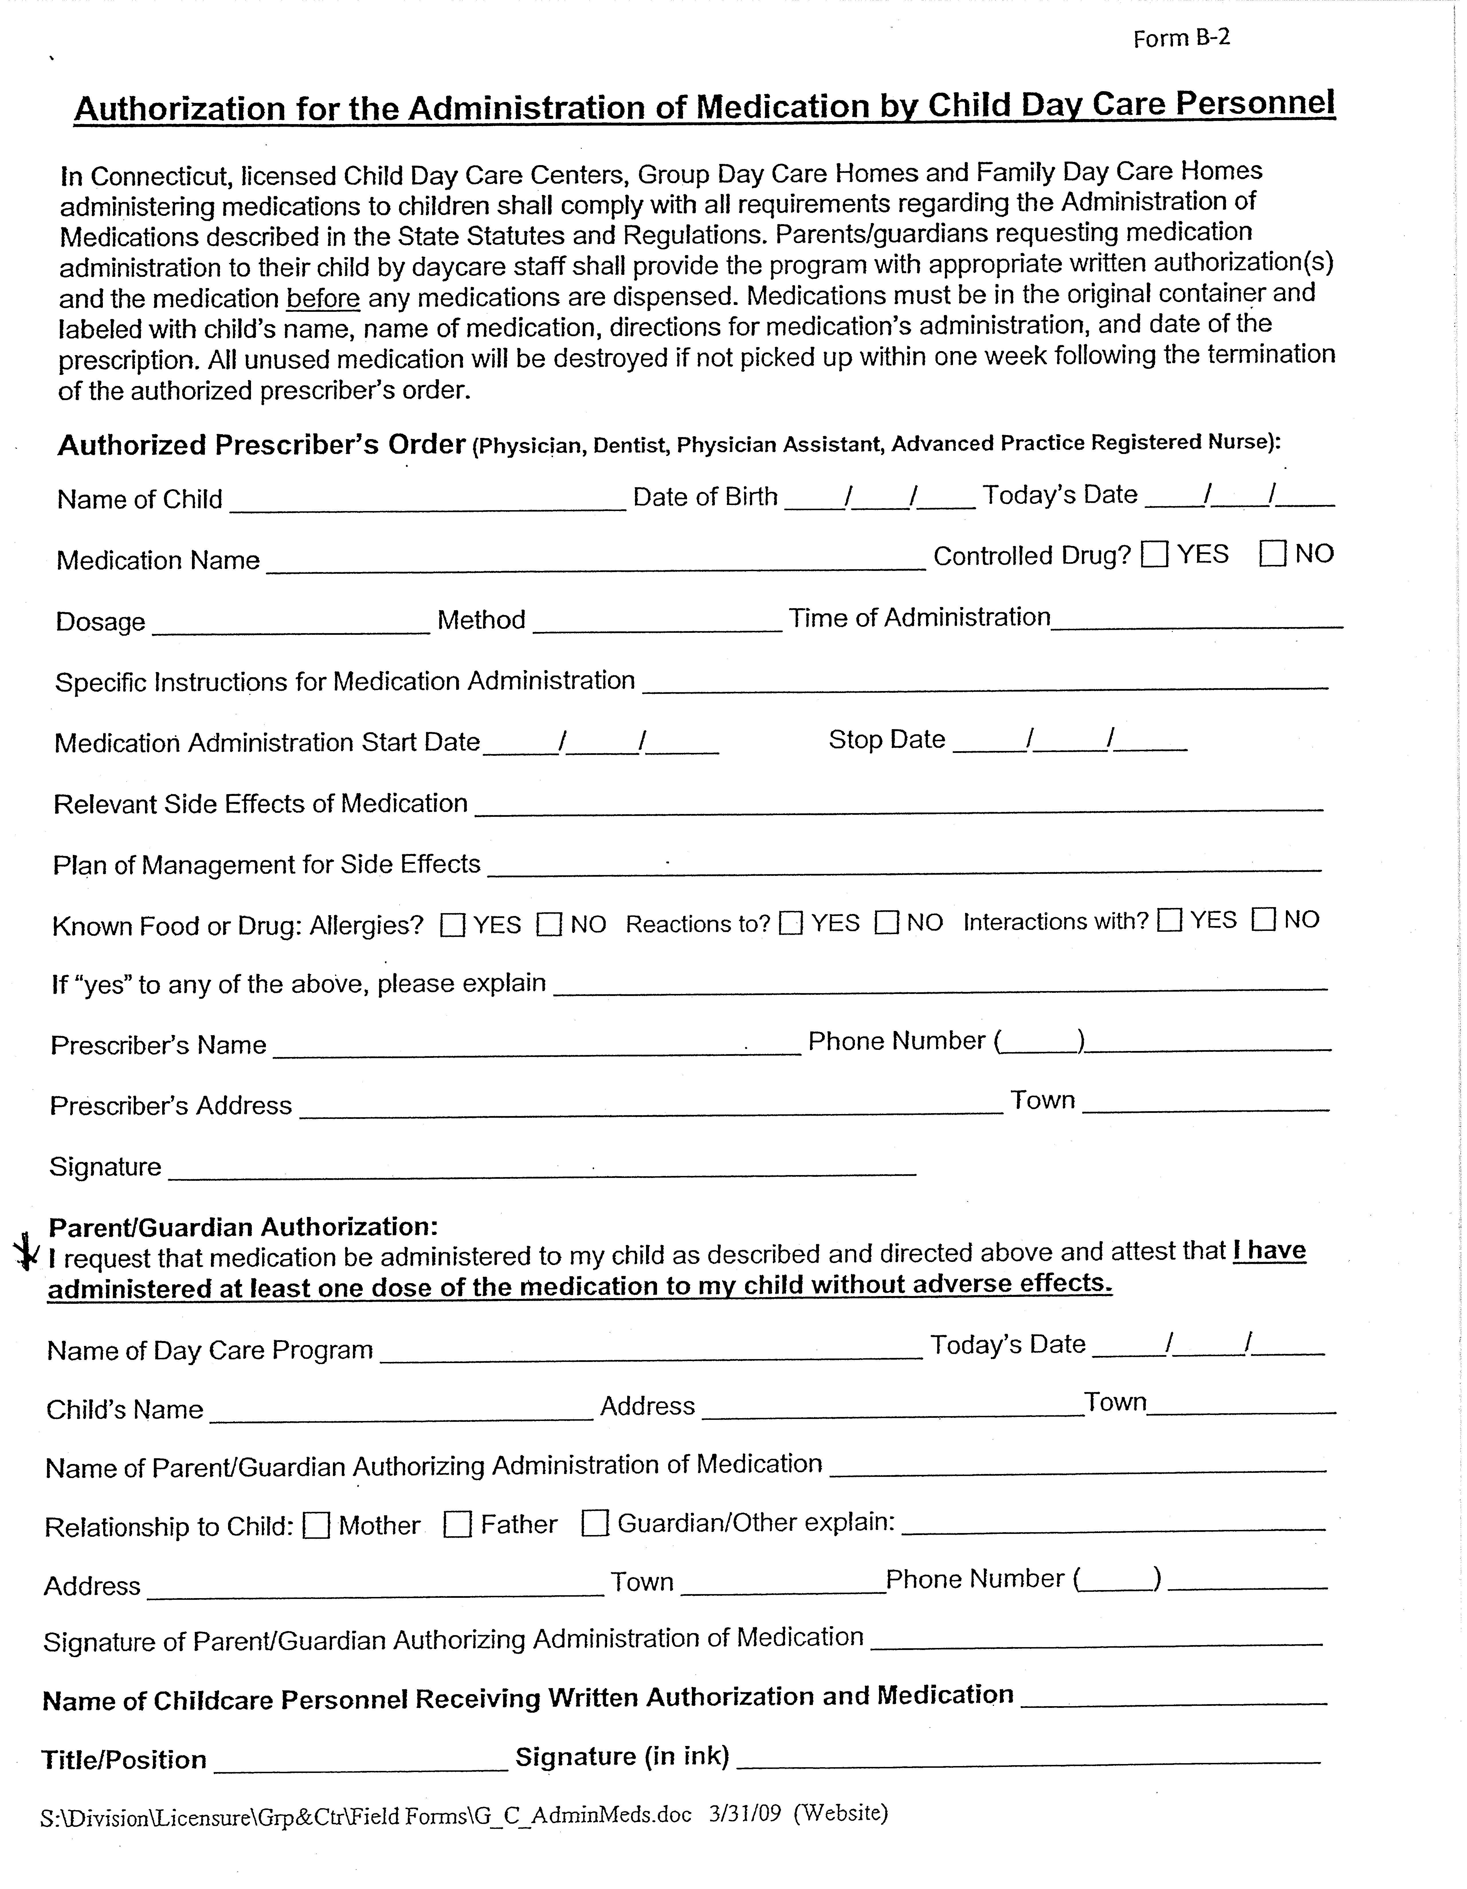

HEBRON PUBLIC SCHOOLS

TRANSFER OF CONFIDENTIAL STUDENT INFORMATION

Date: ___________________

Pursuant to the Family Educational Rights and Privacy Act (“FERPA”), I hereby authorize the Hebron Public Schools and their agents to release and/or obtain (please circle) the following confidential records regarding my child:

Name of Child: _____________________________________________
Address: _____________________________________________
_____________________________________________
_____________________________________________
_____________________________________________
DOB: __________________

Parent(s)/Guardian(s):____________________________________________
School: _____________________________________________

(Please check all that apply)
Obtain Release
All Records □ □
Cumulative File □ □
Pupil Personnel/Special Education □ □
Disciplinary □ □
Health/Medical* □ □
Other (please specify) □ □
_______________________________

_______________________________

To/From: ___________________________________________________________________________
Name
Address: ______________________________________________________________________________
Street Town State/Zip Code

Telephone: (_______)_______________ Fax: (________)_______________________

I understand that the information to be disclosed is protected as an “education record” under FERPA, and that such information shall not be redisclosed unless permitted under FERPA. I further understand that the officers, employees, and agents of any party that receives protected information under FERPA may use such information only for purposes for which the disclosure is made.
___________________________________ ____________________
Signature of Parent/Guardian Date

___________________________________
Print Name of Parent/Guardian
HEBRON PUBLIC SCHOOLS

TRANSFER OF CONFIDENTIAL STUDENT INFORMATION – pg. 2

********************************************************************************************************
*If this authorization is being used to obtain Protected Health Information from a child’s physician or other covered entity under HIPAA, the following section must also be completed:

I, the undersigned, specifically authorize _______________________________ to disclose my child’s
Name of Physician__________________________________________________________,

medical information, as specified above, to my child’s school,
Name of School____________________________________________________________,

at the above address for the purposes described below (i.e. health assessment for school entry, special education evaluation etc.):
_______________________________________________________________________

By signing below, I agree that a photocopy of this authorization will be valid as the original. This authorization will be valid for a period of one year from the date below. I understand that I may revoke this authorization at any time by notifying the physician’s office in writing, but if I do, it will not have any effect on actions taken by the Physician prior to receiving such revocation.

I understand that under applicable law, the information disclosed under this authorization may be subject to further disclosure by the recipient and thus, may no longer be protected by federal privacy regulations.

I understand that my child’s treatment or continued treatment with any health care provider or enrollment or eligibility for benefits with any health plan may not be conditioned upon whether or not I sign this authorization and that I may refuse to sign it.

Any information received by the school pursuant to this authorization is subject to all applicable state and federal confidentiality laws governing further use and disclosure of such information.

___________________________________ ____________________
Signature of Parent/Guardian Date

___________________________________
Print Name of Parent/Guardian

4/6/09
238848 v.36 S5

 |  | 2025-2026 PREP Tuition Fee Schedule
 | MONTHLY RATES:
 |  |  | AM | PM | PM EXTENDED
 | Date | # weeks/mo. | Care | Care | Care
 |  |  | 6:45-8:15 | 3:00-5:00 | 5:00-6:00
 | September
 | (Payment due 8/8) | 4.00 | $196.00 | $344.00 | $360.00
 | October
 | (Payment due 9/19) | 5.00 | $243.00 | $430.00 | $452.00
 | November
 | (Payment due 10/17 | 4.00 | $196.00 | $344.00 | $360.00
 | December
 | (Payment due 11/21) | 3.00 | $147.00 | $258.00 | $270.00
 | January
 | (Payment due 12/19) | 4.00 | $196.00 | $344.00 | $360.00
 | February
 | (Payment due 1/16) | 4.00 | $196.00 | $344.00 | $360.00
 | March
 | (Payment due 2/20) | 5.00 | $243.00 | $430.00 | $452.00
 | April
 | (Payment due 3/20) | 4.00 | $196.00 | $344.00 | $360.00
 | May
 | (Payment due 4/17) | 4.00 | $196.00 | $344.00 | $360.00
 | June
 | (Payment due 5/15) | 2.00 | $98.00 | $172.00 | $180.00
Please note- A credit card MUST
be on file.

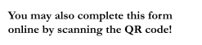

Hebron Public Schools
Alternate Pick Up/Drop Off Request Form
2025-2026 School Year
(For pick up/drop off OTHER than the students primary home address)
Please submit by July 1, 2025
Please contact the Hebron Board of Education Central Office at 860-228-2577 with any questions related to this form. Multiple children can be included on a single form, however, please only use this form for children with identical transportation requests.
Bus routes are developed based on home addresses. Please complete this form each year ONLY if you are requesting a pick up/drop off other than your home address, or if you do not intend to have your child(ren) ride the bus. Requests may be granted under the following circumstances:
- The request is for 3 months or more (exceptions may be granted by the Superintendent in the event of emergencies.)
- There is space available on the bus (preference is given to students who reside on the route; therefore, a student who has received a transportation request may have this permission revoked at any time.)
- The location of the AM pick up and PM drop off may be different but must be consistent Monday through Friday.
- This request will not disrupt the bus schedule as determined by the administration.
______________________________________________ | ________________________
Parent/Guardian Signature | Date
- Any adjustment submitted after July 1st may not be accommodated by the 1st day of school to provide adequate time for bus routes to be mapped. Mid-year adjustments must be submitted 5 business days in advance of the requested start date.
Student Name(s) | Grade for 2025-2026
_________________________________________ | __________________________________
_________________________________________ | __________________________________
_________________________________________ | __________________________________
Requested Start Date:_________________ Student Home Address:_________________________________
Morning Pick Up:
My child will take the bus from their home address
My child will take the bus from an alternate address (e.g: Daycare/Prep/Babysitter)
Supervising Adult’s Name:____________________________________________
Supervising Adults Address:___________________________________________
Supervising Adults Phone Number:_____________________________________ My child will not need bus transportation in the morning.
My child will attend morning PREP and does not need bus transportation. (Gilead Hill students only)
Afternoon Drop Off:
My child will take the bus to their home address.
My child will take the bus to an alternate address (e.g: Daycare/Prep/Babysitter)
Supervising Adult’s Name:____________________________________________
Supervising Adults Address___________________________________________ Supervising Adults Phone Number:_____________________________________ My child will not need bus transportation in the afternoon.
My child will attend afternoon PREP and does not need bus transportation. (Gilead Hill students only)

Program and Weather Cancellations

As stated in the PREP Parent Handbook along with the Contract, the PREP program follows the Hebron Public Schools’ schedule. This includes closures, delays, and early dismissals due to weather, power outages, and other unforeseen circumstances that are out of the control of the Hebron Parks and Recreation Department.

We understand that these unforeseen circumstances are a tremendous inconvenience and sympathize with all families that rely heavily on the PREP program for childcare. When possible, the Parks and Recreation Department will explore every avenue to avoid untimely closures to the PREP program.

In the event of a closure or schedule adjustment to the PREP program, the Recreation Supervisor will contact all participants, via e-mail, as timely as possible.

Weather/Unforeseen Closure Schedule

School | PREP
1 Hour Dealy | 7:45am Opening
90 Minute Delay | 8:15am Opening
2 Hour Delay | 8:45am Opening
Closed | CLOSED
Early Dismissal | NO PM PREP

*Closure Schedule is subject to change based on severity of weather, or closure, to ensure the safety of all participants, parents, and staff.

I hereby acknowledge that I have read and understand the Unforeseen Closure Schedule for the PREP before and after school program. I understand that the Hebron Parks & Recreation Department has the right to adjust the schedule as needed to ensure the safety of all parties involved.

Parent/Guardian Signature: _____________________________________ Date: _______________

